NT2 Matthew, Mark, John
Dr. Marvin J. Effa

Matthew
Author: Early church tradition gives Matthew as the author. He was an eyewitness and did not depend upon other sources such as the fictional “Q” for his material.
Date of writing: The date is uncertain, but Matthew 24 presents the destruction of the temple as still future. Some argue that it is the first written gospel and suggest a date in the 50s. 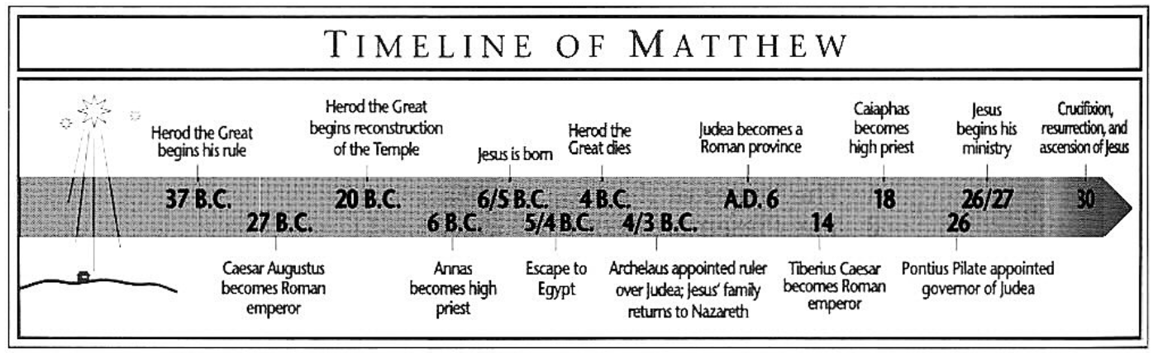
Purpose: To present Jesus as the Messianic king and delineate what happened to the promised kingdom.
Idea: Jesus Christ, the Son of David, is the King of Israel whose kingship Israel rejected and whose kingdom was delayed.
Development:
Matthew: Jesus Christ, the Son of David, is the king of Israel.
- The coming of the King, Matthew 1-4.
- The presentation of the King, Matthew 5-11.
- The rejection of the King, Matthew 12-25.
- The crucifixion and resurrection of the King, Matthew 16-28.
Key chapters:
- The Sermon on the Mount, a polemic against the Pharisees, Matthew 5-7.
- The Rejection Parables, an outline of the period from the rejection until the second coming, Matthew 13.
- The church as a different direction in God’s plan for the world, Matthew 16.
- The Olivet Discourse, an outline of Israel’s future, Matthew 24-25
- The Great Commission, taking the Messiah to the gentiles, Matthew 28.

Parables Pertaining to the Time of Rejection
Matthew 13
Soil | Variety of responses.
Tares | Believers and unbelievers co-exist until the end.
Mustard Seed | Abnormal growth and a home for evil.
Leaven | Evil will completely permeate the visible church.
Treasure | Sacrifice everything for the coming kingdom.
Merchant | Sacrifice everything for the coming kingdom.
Dragnet | Wicked and righteous will be separated at the end.
Householder | The Time of Rejection has new and old truth.

Mark
Author: Early church tradition attributes this Gospel to Mark. John Mark traveled with Paul and was called back into Paul’s service after abandoning the missionary team. Tradition also has Peter providing the material found in Mark’s work. This may be why the authorship has not been questioned.
Date of writing: The date is uncertain.
Purpose: To present to the gentiles the deity of Jesus, the Servant of God. If Peter is the author behind Mark, Peter the Apostle to the Jews, sought to bring the gentiles to Christ.
Idea: Jesus Christ is God, the Servant of the Lord. Each section of Mark contributes to the reader’s understanding of the deity of Christ. The only exception is the John the Baptist narrative, and that section is anticipatory of the truly righteous One’s death.
Development:
Mark: Jesus Christ is God.
- Jesus is the active, teaching Servant, Mark 1-5.
- Like the Baptist, so the Servant, Mark 6.
- The Servant’s teaching, power, and rejection, Mark 7-13.
- Truly the Son of God! Mark 14-16.
Key chapters:
- The rich young ruler, Mark 10.
- The Great Commission of preaching the Gospel, Mark 16.

John
Author: Through the process of elimination, we can conclude that the writer is an Apostle and in a close personal relationship with Jesus as he refers to himself as the one whom Jesus loved. Peter talks about the one Jesus loved, eliminating Peter (John 13:23-24), and James died early in the history of the church (Acts 12), thus John remains as the author.
Date of writing: While most historians give John a later date in the 80s or 90s, the present tense verb in John 5:2 indicates Jerusalem had not yet been destroyed.
Purpose: To provide irrefutable proofs that Jesus is God and is able to give everlasting life to all who believe in Him.
Idea: Everlasting life is freely given to all who believe in Jesus.
Development:
John: Jesus is the Giver of Life to all who believe in Him.
- Israel rejects her messiah, John 1-12.
- Jesus prepares His disciples, John 13-17.
- The Giver of Life gives His life, John 18-19.
- The resurrection and appearances of Jesus, John 20-21.

Key chapters:
- Good people must be born again; Nicodemus, John 3.
- Rejected women may receive life by believing in Jesus, John 4.
- Jesus is the true light of the world, John 8.
- Jesus is the resurrection and the life, John 11.
- A new direction for the Apostles; the Upper Room Discourse, John 13-17.
- The purpose statement of John’s book, John 20:30-31.

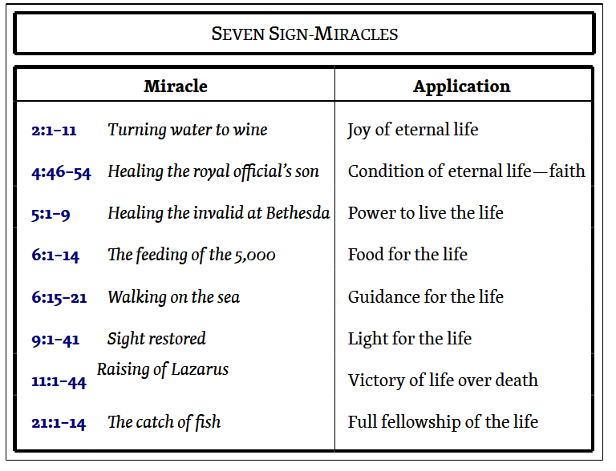 | 